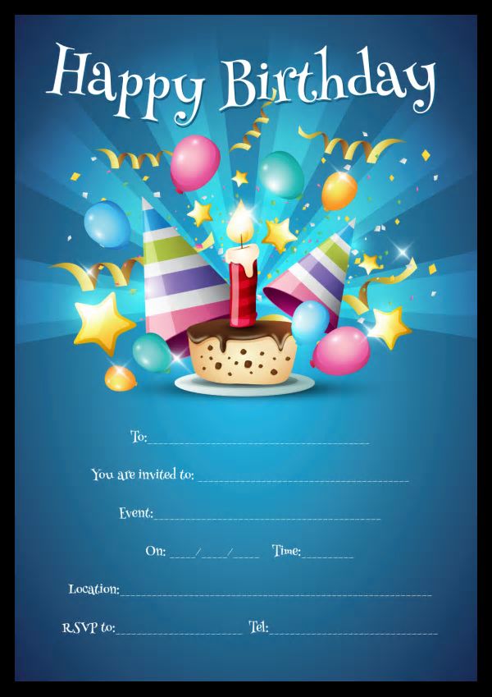

Provided by

King of the castles entertainments 07968633946

Provided by

King of the castles entertainments 07968633946