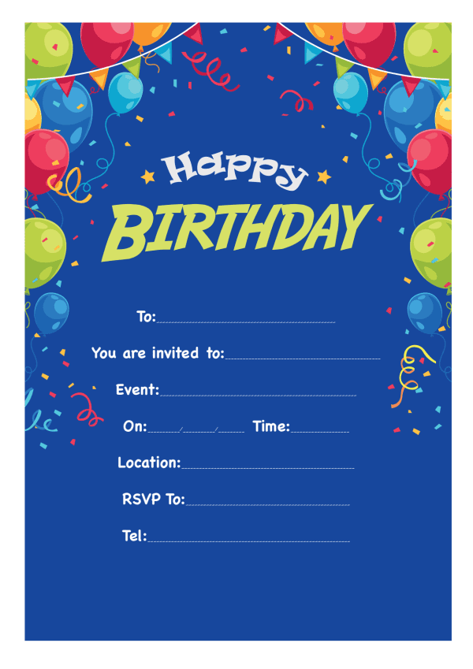

Provided by

King of the Castles Entertainments 07968633946

Provided by

King of the Castles Entertainments 07968633946