Inflatable Assault Course - Risk Assessment 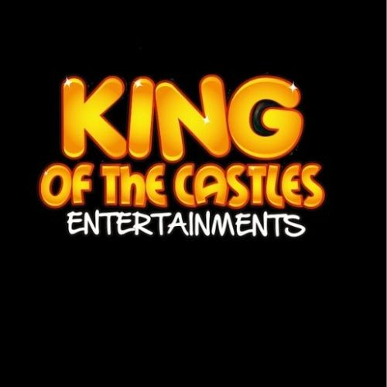

Company: | King of the castles Entertainments | Location (Site / Building / Room): | Events
Assessment Date: | 15 March 2026 | Review Date: | 31 March 2027 (or if changes to the  risk)
Assessor’s Name: | Natalie king | Job Title: | DIRECTOR
Description of Task: | Transportation, Assembly and Use of Inflatable Assault Course Equipment

Description of the hazard (or hazardous  event) | Who might be at risk? | What is the risk? | Evaluation and Control Measures | Current risk rating* |  |  | Identify any additional controls that may be needed | Timescale for additional controls and responsible  person | Risk Rating
 |  |  |  | L | C | R | Identify any additional controls that may be needed | Timescale for additional controls and responsible  person | L  (Low) | M  (Medium) | H  (High)
Loading, Handling and Transportation of Equipment | Operator / Spectator | Injury whilst handling equipment | - Equipment must be handled in the correct manner.  - Manual handling should be reduced to a minimum by using available trolleys / trucks.  - Ramps / Lifts to be used when required and available.  - Loads must be correctly secured.  - Individuals are not to undertake anything that puts themselves or anyone at risk. | 1 | 2 | 2 | - Where required individuals can assist in handling the equipment and adhering to site Manual Handling measures.  - Staff are to wear PPE at all times in accordance with the Clients requirements and site guidelines. | N/A | 2 | N/A | N/A
Installation of Equipment on site | Operator / Spectator Participants | Injury whilst installing the equipment  Damage to venue | a). The equipment is inspected before installation to ensure it is free from damage. | 1 | 2 | 2 | 1.The equipment is secured with 30cm long 20mm diameter metal pegs if installed on grass. | N/A | 2 | N/A | N/A

Installation of Equipment on site (Cont.) | Operator / Spectator Participants | Injury whilst installing the equipment  Damage to venue | - The Operators must have clear access to the setup area.  - The setup area must be level and free from any debris.  - The operator must be notified of any underground services, cable, weight limits, or external factors that may hinder installation of this equipment.  - The equipment should not be installed near overhead power lines.
Ground Type | Operator / Spectator Participants | Injury to Participant | - The equipment can be installed on grass.  - The area must be free from debris and animal waste. | 1 | 1 | 1 | N/A | N/A | 1 | N/A | N/A
Electricity and Cabling | Operator / Spectator Participants | Injury to Operator Injury to Spectator Injury to Participants | - Equipment requires access to 13Amp plug socket.  - Power source should be no further than 40m away from equipment.  - All cabling to be covered where required and routed away from Walkways etc. | 1 | 2 | 2 | 1.Cable matting supplied and used where any cable crosses a walkway. | N/A | 2 | N/A | N/A

Electricity and Cabling (cont.) | Operator / Spectator Participants | Injury to Operator Injury to Spectator Injury to Participants | d). All electrical components are inspected for wear and that they are covered by the 6 month PAT test.
Operation of Equipment on site | Operator / Spectator Participants | Injury to Operator Injury to Spectator Injury to Participants | - Users will be instructed to form a queue in front of the equipment in view of the operator who will control the queue.  - Users must follow the operator’s instructions at all times.  - Users must go through the equipment in the same direction no users are allowed to go against the flow.  - Safety Mats must be placed at the entry and exit points of the inflatable. | 1 | 1 | 1 | - Spectators are to be a minimum of 2m distance away from the equipment and not allowed to sit / rest or interfere with the equipment at any time.  - Where applicable, equipment is to be cleaned after use and using approved cleaning materials. | N/A | 1 | N/A | N/A
User Safety | Operator / Spectator Participants | Injury to Operator Injury to Spectator Injury to Participants | - Participants who appear to be under the influence of alcohol / drugs will be refused access to the equipment.  - The Operator reserves the right to refuse permission to anyone they feel may be unsafe to partake in the activity. | 1 | 1 | 1 | - Where applicable, a Trained Operator will be in control of the equipment at all times who is briefed on the safe running of the equipment.  - Trained Operators receive annual training and updates on the equipment operation.  - The Fun Experts hold no liability for the onset of any medical condition or injury | N/A | 1 | N/A | N/A

User Safety (cont.) | Operator / Spectator Participants | Injury to Operator Injury to Spectator Injury to Participants | - Participants must be wearing suitable clothing for the activity.  - Items of loose clothing must be secured and any watches, jewellery, glasses must be removed or secured prior to taking part in the activity.  - Children must be supervised by an adult at all times.  - Food and Drink inclusive of chewing gum and sweets will not be allowed in the operating area.  - Participants should be aware of their own physical ability and notify the Operator if they want to end the activity.  - Anyone suffering from Heart Disease, physical mobility restrictions, including broken bones, and those who are pregnant should not be allowed to take part in this activity.  - The equipment must be used in accordance with the Manufacturers guidelines. |  |  |  | sustained from partaking in this activity.

Weather | Operator / Spectator Participants | Injury to Operator Injury to Spectator Injury to Participants  (slip / trip/ falls) | a). The equipment can be used indoors and outdoors in mild weather conditions.  - The wind speed should be monitored during the course of the event by the operator and hirer and should not exceed the maximum permitted wind speed of 19mph.  - Should winds exceed 19mph the equipment must be cleared of all participants and deflated until it is safe to inflate and resume the activity.  - In the event of rain, the operator or hirer on the day will assess the conditions and equipment to ensure safe operation.  - The equipment must be dry and safe before resuming the operation. | 1 | 1 | 1 | 1.Winds Speeds are monitored / measured by a supplied Anemometer. | N/A | 1 | N/A | N/A

Risk Rating Calculator (Likelihood x Consequence = Risk)

Likelihood that hazardous event will occur |  | Consequence of hazardous event
1 | Very unlikely | 1 | Insignificant (no injury)
2 | Unlikely | 2 | Minor (minor injury requiring first aid only)
3 | Fairly likely | 3 | Moderate (Up to three days absence)
4 | Likely | 4 | Major (More than seven days absence)
5 | Very likely | 5 | Catastrophic (Permanent injury or death)
Action Level Table

Risk Rating | Risk Level | Actions to be taken
20 – 25 | Very High Risk | STOP! Stop the activity and take immediate action to reduce the risk, a detailed plan should be developed and  implemented before work commences or continues. Senior management should monitor the plan.
15 – 16 | High Risk | Urgent Action! Take immediate action and stop the activity if necessary, maintain existing controls rigorously. The  continued effectiveness of control measures should be monitored periodically.
8 – 12 | Moderate Risk | Action Moderate risks may be tolerated for short periods only while further control measures to reduce the  risk are being planned and implemented. Improvements should be made within specified timescales.
3 – 6 | Low Risk | Monitor Look to improve at the next review or if there is a significant change. Monitor the situation periodically  to determine if new control measures are required.
1 – 2 | Very Low Risk | No Action No further action is usually required, but ensure that existing controls are maintained and reviewed  regularly.

