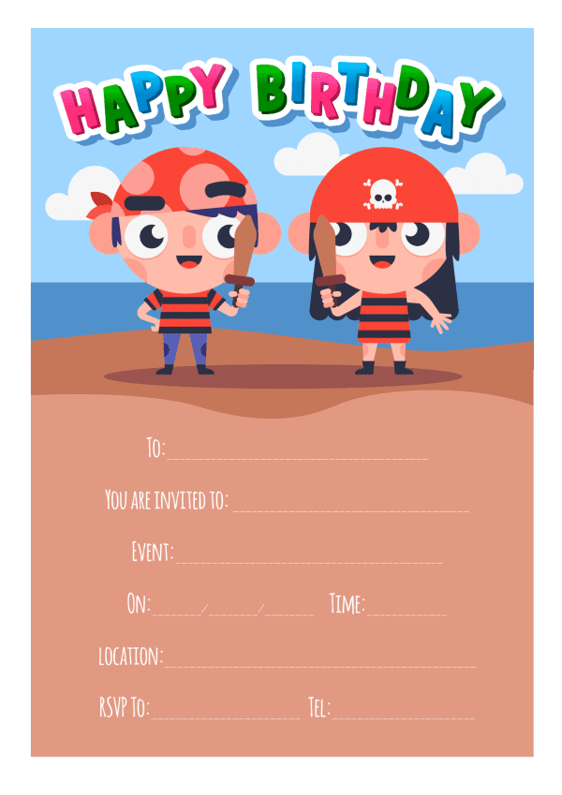

Provided by King of the Castles Entertainments 07968633946

Provided by King of the Castles Entertainments 07968633946