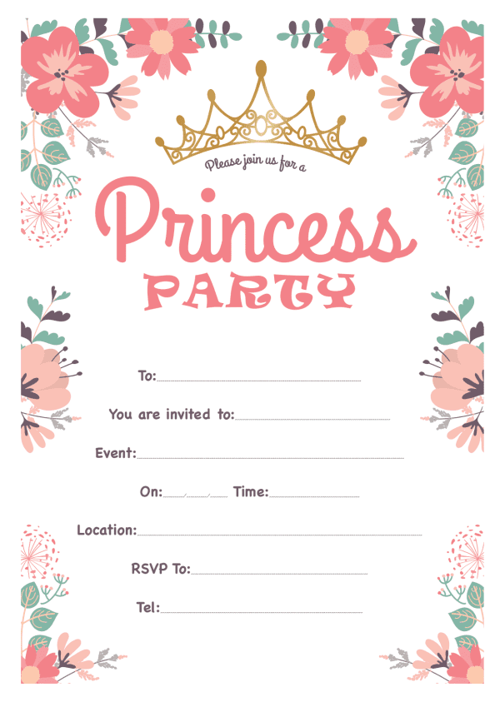6

Provided by

King of The Castles Entertainments 07968633946

Provided by

King of The Castles Entertainments 07968633946